Pennine Sailing Club

OPERATIONS MANUAL
(TRAINING CENTRE)

July 2020
Revised July 2020

- FOREWORD

Pennine SC is a volunteer run organisation that provides a number of typical inland sailing club activities
• Dinghy Racing
• Dinghy Training
• Dinghy Coaching
• Powerboat Training
• Social activities
Pennine SC is keen to support training and coaching as a vital part of its activities. PSC has been an RYA accredited Training Centre for many years. All staff including the Principal are volunteers. The Principal is elected by the membership.
Training is for members only. The purpose of training is to
• To improve the standard of sailing and racing within the club
• To secure the future of the club by attracting new adult and junior members
• To get more members racing and to strengthen the Club racing
• To provide the stepping stones for entry to the regional and national squads
• To get more people sailing more often
• To increase the skills and qualifications of those delivering training - Encourage and subsidise members to attend courses and gain RYA Qualifications as SI, PB2I, DI, RI, PB2’s, RO

SAFETY, RESPECT, CHALLENGE, FUN.

2. INTRODUCTION

These Standard Operating Procedures are designed to ensure that all instructors, assistant instructors and Club members are conversant with the Club’s operating and safety policies when involved with the training activities of the Club. The Principal, Chief Instructor, Senior Instructors will review this document annually or at any time due to any exceptional requirement.
Before commencing any training activity on behalf of the Club, all instructors should be fully familiar with and able to implement the relevant safety guidelines within this document and those as laid down by the RYA as appropriate.

3. MANAGEMENT AND OPERATION OF THE RTC

3.1 Training and Awards
The Training Centre offers training and awards as below:

3.1.1 Sailing
• RYA Dinghy Level 1, Start Sailing
• RYA Dinghy Level 2, Basic Skills
• RYA Dinghy Level 3, Better Sailing, Seamanship skills, Start Racing, Performance Sailing and Sailing with Spinnakers.
• RYA Youth Stage 1,2,3,4.
• Race Coaching
3.1.2 Powerboat
• RYA Powerboat Level 1 and 2
• RYA Powerboat 2 (including PB2 Assessments)
• RYA Safety Boat
3.1.2 Other
First Aid

3.2 Qualifications
Pennine SC is committed to providing high quality training. All staff, instructors and assistant instructors must be suitably qualified.

3.3 Roles and Responsibilities

3.3.1 The Principal
The Principal is in charge of the Training Centre. Overall and final responsibility for safety and standards of training rests with the Principal. In matters of policy and resources the Principal works with the Commodore and the Committee to ensure that the club satisfies the requirements of the RYA and in the annual inspection to maintain RTC recognition.
• The Principal with the approval of the General Committee may appoint other Senior Instructors or another Senior Instructor to be Chief Instructor.
• The Principal will ensure that time is set aside for their briefing, familiarisation with the SOPs and any revisions that become necessary.
• The Principal may, with the approval of the Committee, appoint suitably qualified Instructors and Assistant Instructors.
• The Principal will ensure that suitably qualified instructors and other staff are available for the courses.
• The Principal will inform the Child Protection Officer of the Instructors, AIs, volunteers so that they can be familiarised with the Clubs Child Protection Policy, the Guide to Good Practice, and sign a self-declaration form or apply for a DBC.
• The Principal will ensure that new instructors, AIs and volunteers are familiar with the site specific operating procedures by providing the documents for reading and if required being available to discuss. New instructors, AIs and volunteers may be required to shadow the SI, I’s, AIs or other experienced volunteers. If they do so they will be counted in the ratios as AIs or volunteers respectively.
• The Principal will update the training of the returning instructors, AIs, volunteers at Training
Committee Meetings or at other times as necessary.
• The Principal, or if one is appointed the Chief Instructor has the day to day responsibility for the running of the courses, standards of training, equipment maintenance and well-being of the instructors, students and volunteers.
• The Principal will appoint an SI to be in charge of each dinghy sailing course.
• The Power Boat courses will be led by a Powerboat Instructor appointed by the Principal.

3.3.2 Chief Instructor
The Chief Instructor (if a separate person is appointed) will have the day to day responsibility for;
• the running of the courses
• standards of training
• equipment maintenance
• well-being of the instructors, students and volunteers
• issuing and signing RYA certificates in the discipline in which they have qualifications.

3.3.3 Senior Instructors
A Senior Instructor will be present at all training events and will be accountable for their safe conduct and successful outcome. (Occasionally an instructor whom the Principal is satisfied
has sufficient competence may be appointed to run a single session.)
The Power Boat Courses will be led by a Power Boat Instructor.

3.3.3.1 Safety
The over-riding responsibility of the SI and other training staff is the safety of the trainees and of themselves and other users of the reservoir. If the conditions encountered, the composition of the group or the equipment available give sufficient cause for concern that the safety of the group cannot be assured, for the planned activities then alternative activities probably in the training room should be undertaken. However, if the site becomes unsafe all activities should be postponed and rearranged.
No personnel or trainees shall be under the influence of alcohol, drugs or medication that affects their physical abilities or judgement.
Instructors / trainees shall inform the Principal/SI if they are unwell / become unwell so they cannot complete a session.

3.3.3.2 Instructor Ratio
The SI will ensure that there are sufficient instructors, AIs, volunteers to carry out the training sessions. RYA Ratios for sailing tuition are;
Dinghy sailing
• Level 1 Double- handed 1:3 (I/AI : trainees)
• Level 1 and/or 2 Single-handed 1:6 (However juniors may need 1:3 or lower depending on confidence and conditions)
• Level 2 Double-handed 1:3 (Until the trainees are confident sailing without an instructor aboard)
• Level 2 Double-handed 1:6 (Once trainees confident sailing without an instructor aboard)

3.3.3.3 The weather
The SI will:
Be responsible for deciding if conditions for the planned activities are suitable for the trainee group considering their level of experience, instructors and equipment available.
Ensure that Instructors and trainees are suitably clothed. Special consideration shall be given to clothing in cold weather and to clothing and sun protection in hot weather. Wet suits, dry suits, or other modern specialist dinghy clothing may be needed.
Make contingency plans if the planned activities cannot take place e.g. insufficient wind or too much.

3.3.3.4 Equipment
The SI will ensure:
• That all safety equipment is checked and conforms to the standards required of the RYA, and that power boats are available in sufficient numbers to meet the standard ratios advised by the RYA and are manned by suitably qualified drivers.
• That the following items are carried by Instructors on each session, should include:
Serrated bladed knife
Whistle
Length of cordage/tape
• That the sailing craft to be used for training are in good condition and are available in sufficient numbers to match the number of trainees.
• That the radios are in good working order.

3.4 Specific Responsibilities in Summary
Specific responsibilities of the Senior Instructor include:
• Working within PSC Health & Safety, PSC Child Protection Policy and the TC SOPS. Therefore, Sis shall sign to confirm that they have read and understood the documents and can conform to their requirements.
• Allocation of boats and equipment
• Selecting sailing / operating areas
• Briefing staff
• Monitoring activities, staff and trainees - safety, wellbeing and progress
• Safety cover
• Debriefing staff
• Risk Assessment
• Equipment returned / Maintained
• Ensuring that all containers and the key safe are locked at the end of sessions
• General administration in conjunction with the Principal

Specific responsibilities for Instructors include:
• Working within PSC Health & Safety, PSC Child Protection Policy and the TC SOPS. Therefore I’s & AI’s shall sign to confirm that they have read and understood the documents and can conform to their requirements.
• Attend site of activity in sufficient time to prepare for the sessions.
• Attend briefings
• Wear appropriate clothing for the planned activity
• Carry out allocated duties in a professional manner
• Check that participants are correctly dressed for the activity and are wearing appropriate safety equipment correctly
• Supervise participants in correct safety, handling, launching and recovery procedures and always encourages a sense of responsibility to others and in the use of the Sailing Club’s equipment.
• If asked to work directly with SI, other Instructors, AIs, volunteers will work as a team, to deliver the planned activity.
• If given own group prepare a suitable session plan bearing in mind the age and experience.
• To constantly monitor the well-being of the trainees and if necessary stop or adapt sessions so that trainees are challenged and responsive but not unduly stressed or exhausted.

Specific responsibilities for volunteers
• Attend site of activity at agreed time
• Attend briefings
• Wear appropriate clothing for the planned activity
• Carry out agreed duties in a responsible manner
• To follow the instructions and guidance of the SI and Instructors
• To seek further guidance from the SI/I if uncertain of how to carry out any task allocated

3.5 Areas of Operation

3.5.1 Sailing Area
No sailing is permitted close to the dam wall.
The overflow is included in the prohibited area.
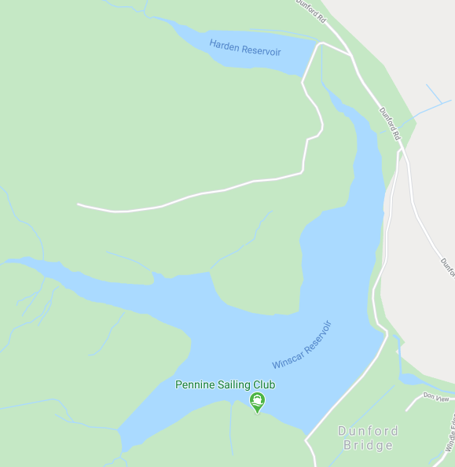
Dam Wall
Club House

3.5.2 Waterfront / Slipway / Beach / Boat Park
It is a requirement that safe practices are observed on the slipways and that the roadway leading to the slipways is not blocked by boats being rigged for sailing. This area often has members of the public who will be unaware of the hazards of rigged dinghies
SI/Instructors will manage the boats on the slipway/rigging area and berthing areas and instruct trainees in safe practices and to ensure that the instructions are followed.
Trainees should be warned of the deep water next to the slipway

3.5.3 Clubhouse

Changing Rooms / Toilets
It is the responsibility of everyone using the facilities to behave sensibly in the changing rooms considering the well-being and safety of other users. Parents are responsible for the behaviour and supervision of their children in the changing rooms/toilets. Instructors and volunteers are asked to try not to use the changing rooms at the same time as Juniors and especially if there are no other adults there.
No mobile phones or other electronic devices are to be used in the changing rooms or toilets.
This area is shared with other users and may be accessible by the public. No valuables should be left in the changing rooms.

3.5.4 Containers 1 & 2
Trainees should not enter these unless specifically requested to by SI or Instructors. The RIBs are stored in the containers and care should be taken when inserting and removing them and when towing down to the waterside.

3.6 Participant Clothing
Personal protective clothing, which is appropriate to the activity, should always be worn. Instructors shall not allow anyone whom they consider not wearing the appropriate clothing to take part in any activity.
Instructors shall monitor the well-being of trainees and shall modify stop activities if participants clothing becomes inadequate.
Additional clothing or safety equipment to cope with sudden changes in the weather or conditions should always be carried.

3.6.1 Personal Buoyancy
A minimum of 50 Newton’s or equivalent must be worn at all times when on the water. Buoyancy Aids are made available to all trainees, and it is the responsibility of the instructors to choose suitable buoyancy aids and to ensure a correct fit for the trainees. Instructors should check that buoyancy aids are being worn correctly before trainees go on the water.

3.6.2 Footwear
Dinghy boots are not mandatory, but trainees are advised to wear suitable soft footwear e.g. trainers to afford good grip and to avoid boat damage.

3.6.3 Helmets
All children below 14 years of age are required to wear helmets whilst they are beginners. Above 14, it is up to the individual to choose whether or not to use a helmet.

3.6.4 Cold and Hot Weather Clothing
Special consideration shall be given to clothing in cold weather when the water temperature is below 12 C and to clothing and sun protection in hot weather. Wet suits, dry suits, or other modern specialist dinghy clothing may be needed. Long trousers and long sleeved shirts, sun screen, sunhats, and sunglasses may be needed in hot weather.
A wetsuit or dry-suit must be worn when the water temperature is below 12° C Wet suits are available within the Club and are stored in ‘Box’ 4.
Dry suits are not available within the Club, but any trainee in possession of same will be advised of the suitability/need of wearing it.

3.7 Maintenance of Equipment
All equipment including dinghies and powerboats, is checked on a regular basis and before use on each session. It is the responsibility of all instructors to report any defective/damaged equipment in the repair book. The SI/Bosun will arrange/ undertake repairs at the earliest opportunity, in the meantime a “do not use / Unserviceable” sign should be put on the defective equipment and if possible removed to a storage area until repaired. Defective equipment must not be used.

3.8 VHF Radios
A 2-way radio must be employed when afloat. Channel 37 (M1) is used to communicate with the
Club’s other radios. The Clubhouse has a fixed radio which should be on.

4. WORKING WITH YOUNG PEOPLE UNDER 18
Safety, respect, good teaching, challenge and fun should be the key watch words. If these things are present it is highly likely that every session protects the welfare of children, parents, instructors and volunteers and allows all to participate in our sport. In line with RYA policy to make sure that best practice is followed Pennine SC has a Child Protection Policy, a Child Protection Officer (CPO) and procedures to further ensure the welfare of children and vulnerable adults.

All staff shall familiarise themselves with PSC Child Protection Policy and follow the Good Practice Guide. All staff over 18 shall sign a self-declaration form and if requested by the Principal or the CPO complete a Disclosure and Barring Application.
Juniors under 13 must be signed in and out for each session, by their parents, who must leave an emergency number and stay on site during all activities. Parents are also responsible for supervising their children in the changing rooms.
Juniors 13-16 must sign in and out for each session, and must leave an emergency number.
Parents may go off site but must collect their children on time.
Juniors 16-18 may sign themselves in and out each session provided their parents/guardians have previously given permission for them to attend
on the application form. They must give an emergency number for their parents/guardian.
Special care must be taken at all times to ensure that the sessions and tasks are suitable for their age, abilities and experience.
Appropriate supervision, guidance, motivation and praise must be given to ensure that Juniors are ‘on task’ and work positively to improve skills and carry out necessary tasks.

5. FIRST AID AND ACCIDENT PROCEDURES
5.1 First Aid
• All instructors must hold a current first aid certificate
• All instructors when working from a safety boat are responsible for ensuring that a First Aid kit is available on the boat.
• All instructors and safety crews must be aware of the dangers of contracting disease from spilt bodily fluids, especially Hepatitis and HIV. Staff should where possible wear protection (such as gloves) against bodily fluids.
• First Aid kits are available at
Each PSC Safety Boat
In the Clubhouse

5.2 Accident Procedures
As soon as any incident accident or injury is notified to an instructor, the instructor shall take action to STOP the incident, PREVENT the injury becoming worse and to AID the recovery of any casualty. The incident should be assessed and dealt with according to the severity of it
• Minor Incident
• More Serious Incident that can be handled easily
• A Major Emergency that imposes a risk to the health or safety of an individual

5.2.1 Minor Incident
The Instructor shall, if the incident is sufficiently minor, deal with it himself immediately without assistance, while still looking after the safety of the group. After immediate First Aid, the casualty may resume activity if fit, or be evacuated to the shore and supervised. Parents should be informed and advised of nature of incident and injury immediately / or at the end of the session. Juniors may be handed over to their parents if present on site, who will sign them out. Parents of 13-16s and 16-18s who are off site may be contacted using their emergency number and may collect their children early and sign them out.

5.2.2 More Serious Incident
The Instructor/safety crew/volunteer shall summon assistance of another safety crew/Instructor or SI and if they can deal with it immediately without further assistance while looking after the safety of the rest of the group/groups they should do so. The other members of the group shall be assured that all is being done for the casualty The Instructor/safety crew/volunteer shall summon assistance from other safety boats.
After immediate First Aid, the casualty should be evacuated to the shore and supervised.
Parents should be informed and advised of nature of incident and injury immediately/or at the end of the session. Juniors may be handed over to their parents if present on site, who will sign them out. Parents of 13-16’s and16-18s who are offsite may be contacted using their emergency number and may collect their children early and sign them out.

5.2.3 Major Emergency
If the incident is more serious the Instructors / Senior Instructor should go to the Emergency Action Plan.

5.2.4 All Accidents or Incidents
All incidents, accidents and emergencies are to be logged in the Club Accident Book. Any NEAR MISSES i.e. any incident that causes concern because it could result in injury if it happened again should be reported to the SI in the debrief and discussed The SI will then enter the event into the Club Near Miss Log. If the instructor is unable to discuss the matter with the SI he should enter the email the Principal with details and then as soon as practical inform the SI.

6. POWERBOAT USE
All powerboat drivers must be qualified to powerboat level 2. All powerboats must be used with kill-cords, which are attached to the driver and kill switch.

6.1 Petrol
Petrol for the safety boats is stored in the locked Fuel Store. Care is to be taken when fuelling boat to avoid spillages/
6.2 Mandatory User Checks
• Check the internal or external tanks to ensure adequate fuel for the sessions is available
• Check fuel lines for leaks and damage
• Check the external fuel tank is tied in (if used)
• Check propeller for security and damage
• Check all controls are working satisfactorily
• Check hull and for damage
• Check rib sponsons are correctly inflated (pump is available)
• Check that the safety kit is taken afloat.
• Check the bungs are present and secure
• Check that warps, anchor, paddle, and tow-lines are present.

6.3 Launching and recovery of Powerboats
The SI will supervise the launching/recovery of the safety boats or appoint an Instructor / Assistant Instructor / experienced volunteer / club member to do so.

However, the following extra precautions should be taken with trainees present.
• Extra vigilance to see the slips and roadways are clear before rolling the boats out of the containers.
• Extra vigilance to see that no people are behind the Power Boat as it goes down the slipway.
• Extra care to see that adequate manpower is used and that the team understands and follows the directions of the person in charge.
• Ideally any small, young juniors will be in a briefing or debriefing away from the slipway and roadways.

6.4 Engine starting
• Ensure there is adequate depth of water to lower the engine before starting.
• Insert the kill-cord and switch to "on".
• Check the engine is in neutral.
• Start engine using key or pull cord, adjusting choke and fast idle settings if appropriate.
• Look for the water expulsion ‘tell-tale’ from the engine. If no tell-tale after a few seconds or if it is weak stop engine and do not use until serviced or repaired.
• If the engine jumps into gear upon starting do not use until serviced or repaired

6.5 Driving the powerboats
• Keeping a good lookout is key for safety.
• Hazards should be given a wide berth.
• Kill cords are to be used at all times when the engine is running.
• No joy rides to be given.
• Passengers may be taken for specific training purposes e.g. transferring between dinghies, to view demos.
• If passengers are taken, full instructions as to seating and holding on and warnings of changes in direction shall be given.
• Care must be taken not to compromise safety if the powerboat is being used to give safety cover.
• Drivers must be constantly aware of the potential of injuries that the propeller can cause to people in the water and people that fall overboard from powerboats.
• Engines are to be stopped immediately anyone falls overboard or if anyone is in the water in the near vicinity of the powerboat or when attempting to pick up persons in the water.
• Speed should always be appropriate. High speed and waves can cause back injuries.
• Care must be taken to limit damage and disturbance by wash in enclosed areas.
• Every driver has a responsibility to avoid damage to propellers, engines and boats wherever possible.

6.6 Safety Boat Emergency Kit
See RYA centre guidance notes for Safety Boat equipment checklist.

7. COURSE MANAGEMENT: DINGHY TRAINING

7.1 Recruitment and Administration
The Principal is responsible for taking bookings for the training courses, and will discuss by email/phone with potential trainees (or their parents if they are juniors) to give them the course information and to check on their health and previous experience before accepting their applications. All applicants must be members of the club and have paid the appropriate membership fee. (The Principal may appoint a Training Co-ordinator to manage recruitment.) The Child Protection Officer is responsible for the Child Protection Policy advising training staff and parents of junior trainees of their responsibilities.
The club membership forms, course application forms and medical forms/health declaration forms, course information, course outlines and feedback forms
There is complaints procedure and a complaint form.

Trainees must fill in
• A Club Application form (if not already a member)
• A Course Application and Medical Disclosure Form including an acceptance of the risks.

During the course, the Principal will ensure that adequate records are kept:
• A register will be kept of attendance on the course, and the success or otherwise
• Records will be retained and certificates will be recorded in accordance with RYA
prescriptions.

7.1.1 Taster Sessions open to the public
At the discretion of the Club, in conjunction with the Principal, the processes for “Taster Sessions” may be relaxed. However, members of the public undertaking these sessions should provide their name and be given a Risk Statement and opportunity to advise of any medical conditions that could be relevant.

7.2 Induction
All trainees are expected to attend an initial induction session that outlines the basic local rules, familiarisation of the club and its facilities/equipment, safety requirements and the format of the training course. Each participant is issued with a copy of RYA publications G11 or G4 plus G3 or G12 or others as appropriate for the course. The course will follow the RYA G4/G11 etc format although the order of tuition may vary at the discretion of the SI depending on weather conditions.

7.3 General Principles
The decision to carry out an activity rests with the Senior Instructor. It is the responsibility of the SI on site to decide upon a suitable location for an activity considering other water users.

7.4 Before Going Afloat
The SI and Instructors will set a logical sailing area for the prevailing weather, and taking into consideration other water based activities on the day. The evacuation of sailors to safety without compromising the safety of other participants must be thought through.
The SI should ensure the following:
• Instructors/AIs/volunteers should be briefed before the trainees arrive.
• Communication systems are set up and tested
• All staff and participants are adequately dressed, including personal protective clothing.
• All staff and participants are wearing a suitable and correctly fitted buoyancy aid.
• Trainees have been briefed
• The safety boat must be afloat before allowing sailors to launch.

7.5 Instructors, Assistant Instructors, Volunteers
Briefing
The SI will cover
• Weather forecast
• Trainees expected number age experience
• Session aim/objective
• Allocation of Instructors/AI/Volunteers duties/Trainees/Boats
• Timings
• Signals/Radios
• Safety Cover
• Area of Operation/hazards/precautions
• The management of the headcount / number of boats.

7.6 Arrival / Signing on
The SI / I shall meet trainees upon their arrival. The parents of juniors shall supervise their children changing if required and then sign them in. Adults and Youths aged 13 - 18 shall sign themselves in giving an emergency contact number. The trainees will be gathered together or supervised in tasks to make ready for activities.

7.6.1 Trainees’ Briefing
The trainees should be briefed before going afloat or before starting a land-based session as follows
• Aims and objectives given
• How to do it, explanation /demo
• Where to sail
• Stay with the group
• Tell the safety boat/instructor if want to go ashore.
• Signals to be used
• What to do in an emergency, e.g. hove to, stay with the boat
• Wind direction strength and weather
• Hazards identified and precautions taken
• Clothing, rigging, launching, gathering instructions
• Timing and return to shore, beaching instructions.

7.7 Rigging
Each dinghy should be given a thorough check by the coach or instructor to ensure that it is suitably and safely rigged before going afloat. Don’t forget the bungs!!!!
Beginners should be supervised and instructed in techniques to avoid personal injury.
7.8 Launching
Boats may only be launched and brought ashore at the slipway. No boats should be launched until the safety boat is on the water and the SI/Instructor gives permission. Instructors are to check each trainee is suitably dressed, wearing a suitable buoyancy aid which is correctly fastened. Instructors are to check each boat and supervise launching. Instructors to train trainees in teamwork and buddy system to ensure safe and seamanlike launching and to ensure trolleys are parked safely on the shore and not left in the water.

7.9 Head Count/Number of Boats Launched.
The SI shall be responsible for managing a head count and recording. He may delegate to an/each instructor or the safety boat crew the Sign–In sheet and the responsibility of recording the head count once afloat.

7.10 Afloat
In addition to the briefing, the following items should be considered when supervising the participants afloat.
• The effectiveness of the communication system
• The weather situation
• The objectives of the session
• Instructions, discussions and feedback should be given by use of signals and going alongside hove-to boats to talk to trainees.
• When concentrating on an individual, be aware of what is happening around you.
• The head count should be checked regularly.
• Be aware of, and prepared to respond to, participants on the edge of the sailing area.
• Make the best use of time, don't allow participants to become over exerted and be aware of
the effects of cold or bad weather. A short, focussed, positive session is far more effective than a long, arduous struggle.
• Dynamic risk assessment actioned, i.e. wind rising consider reefing or going to shore.

7.10.1 Signals afloat
• Raising and lowering of one/both arms = I need assistance.
• One raised arm (by dinghy sailor) = I have a question / I want to tell you something.
• 1 whistle and point at one dinghy = stop what you are doing and stop the boat
• 1 whistle and beckon at one dinghy = stop what you are doing and come to me / follow me
• 2 whistles and hands to head= everyone stop what you are doing and come to me / follow me
• 3 whistles and point to shore = everyone go home

7.11 Powerboat Operation
The powerboat is used for:
• Provision of safety cover
• Group control
• Teaching platform
• Communication to participants
• Rescue of all waterborne craft once the safety of all sailors is assured

7.12 The Committee Boat
The Committee boat may be used by an Instructor as any of
• a committee boat
• a teaching platform
• an observation platform
• an emergency place of safety.
• Special Care needs to be taken if trainees are to transfer to the committee boat. It is unlikely that trainees will have sufficient skill to come alongside safely themselves. However, transferring from PB to the committee boat for rest, treatment, recovery or teaching may be considered.

7.13 Beaching and derigging, berthing
• Before beaching the group should be gathered and instructions for beaching given.
• If possible an Instructor should go ahead and be ready to receive the boats and to supervise the depowering, trolleying up of boats and hauling up the slipway.
• Instruction in the correct techniques and management of the equipment is needed.
• Boats should be secured, access left clear, all equipment stowed properly.
• Any damage should be noted in the appropriate book

7.14 Debriefing of Trainees
• Trainees to be debriefed by their instructor on the session- recognition of progress and feedback for improvement given. Objectives set for the next session.
• Debrief on final session trainees to be congratulated on their achievements, log books signed and recommendations for certification given to the Principal. Trainees with sections of the course not signed off shall be offered further training

7.15 Signing off
Parents should collect their children and sign them off after the debriefing. Ideally changing can wait until after the debriefing. Parents are responsible for supervising the changing of their children.

7.16 Staff debriefing
The SI is to lead any final putting away of kit/safety boats
• SI and Instructors to de-brief on the management/ success/problems of the session, and objectives set for the next session(s).
• Accidents/ Near Misses to be discussed and recorded in the appropriate place
• Damage to be reported, marked “Do Not Use / Unserviceable” and recorded in the Maintenance and Repair Book. Damaged items to be removed from use.

7.17 Final site inspection and locking up
There should be a final site check to see that all is as it should be.

8. COURSE MANAGEMENT: POWERBOAT TRAINING

8.1 Recruitment and Administration
The Principal/ Training Co-ordinator is responsible for taking bookings for the training courses, and will liaise with the Power Boat Instructor on the capacity depending on boat availability.
Records will be kept of all trainees, including
• A Club Application form (if not already a member) and sign acceptance of risks
• A Course Application Form
• A Medical Disclosure Form
• A register will be kept of attendance on the course, and the success or otherwise
• Records will be retained and certificates will be recorded in accordance with RYA prescriptions.

8.2 Induction
All trainees are expected to attend an initial induction session that outlines the basic local rules, familiarisation of the club and its facilities/equipment, safety requirements and the format of the training course. Each participant is issued with a copy of RYA publications Start Power Boating. The course will follow the RYA syllabus although the order of tuition may vary at the discretion of the SI depending on weather conditions.
The following safety procedures should be read by all trainers instructing power-boating, staff should use dynamic risk assessment as the session commences and be aware of hazards as they affect their remit as a power-boating instructor.

8.3 Safe Use of Powerboats
• The instructor leading the session must ensure safe lifting practices with engines and equipment.
• A buddy system should be used for launching the boats.
• Correct use of equipment and stowage of boats equipment when afloat and ashore.

8.4 General Principles
The decision to carry out an activity or not is the responsibility of the Powerboat Instructor unless the Principal is present. It is the responsibility of the PBI on site to decide on suitable locations for activities to take place considering other water users.
The PBI shall be prepared to assist other users of the reservoir if required whilst ensuring the safety of his own group. This will be in accordance with the Emergency Action Plan.

8.5 Before Going Afloat
The PBI should ensure the following:
• All staff and participants are adequately dressed, including personal protective clothing.
• All staff and participants are wearing a suitable and correctly fitted buoyancy aid.
• The operational area is large enough to avoid congestion and collisions.
• He is aware of the hazards and ensures precautions.
• He has carried out the Mandatory User Checks for each boat on the course.
• He has ensured the Power Boats have the necessary safety equipment aboard.
• He has set up 2 kill cords for the boat if trainees are under 16 and for PB1 and 2.
• He has briefed the trainees as below and checked their understanding by asking open questions e.g. What/Where/How
• He has a register of participants with their next of kin left on shore.

8.6 Briefing for trainees
The Instructor should ensure that Trainees have been briefed on the following
• Aims and objectives
• Signals and the importance of communication to manage the group and to give effective tuition.
• Operational area depth, hazards identified and precautions to be taken.
• The importance of keeping a good look out.
• The importance of appropriate speed
• The use of the kill cord and the potential damage / injury caused by propeller.
• The correct safety kit to be carried.
• The importance of the Mandatory User Checks
• The proper seating positions and holding on. Warning of starting off, changes of direction.
• Dangerous practices e.g. sitting on / in the bow, dangling arms in water.
• Use of buddy system/teams when lifting and carrying the equipment launching and beaching.
• Care of spare equipment so it is not left as a hazard to other users / members of the public especially the safe location of trolleys.
• Engine lowering/lifting, locking specific to each PB (if trainees operating PB by self)
• Engine starting / restarting procedures
• Signs that engine should not be used/stopped.
• Action on running aground/ in case imminent of collision
• What to do in an emergency.
• The operation of the radios if possible.

8.7 While afloat
• The PBI shall keep a good look out for other craft entering the operating area and encourage the trainees to assist.
• The PBI shall ensure appropriate speeds and safe operating procedures are conformed to.
• If other craft enter the operating area he shall modify or stop activities until safe to resume.
• The PBI shall operate a dynamic risk assessment e.g. “the weather is worsening this exercise is no longer safe. Therefore, I will change activity or go to shore if necessary.
• The PBI shall monitor the well-being of the trainees and if necessary change activity/go to
shore.
• The PBI will use the 2nd kill cord to prevent accidents as necessary.
• The PBI will provide feedback to the trainees.

8.7.1 Signals afloat
• Raising and lowering of one / both arms = I need assistance.
• One raised arm (by trainee) = I have a question / I want to tell you something.
• SI/I or Safety Boat crew: 1 whistle and point at one boat = stop what you are doing and stop the boat
• 1 whistle and beckon at one boat = stop what you are doing and come to me/follow me
• 2 whistles and hands to head = everyone stop what you are doing and come to me/follow me
• 3 whistles and point to shore = everyone go home

8.8 End of Session
On coming ashore:
• Boats and equipment should be put away
• Kill Cords and Ignition keys should be locked away in the container.
• Access left clear.
• Buoyancy Aids and helmets put away

8.9 Debriefing of the trainees
The session and the progress should be discussed and plans made for the next session.
After the final session log books, should be signed and recommendation for the issue of licences and their online registration made to the Principal. The trainees must provide a passport photo. Trainees with sections not signed off shall be offered further training.

8.10 Final site inspection and locking up
There should be a final site check to see that all is as it should be

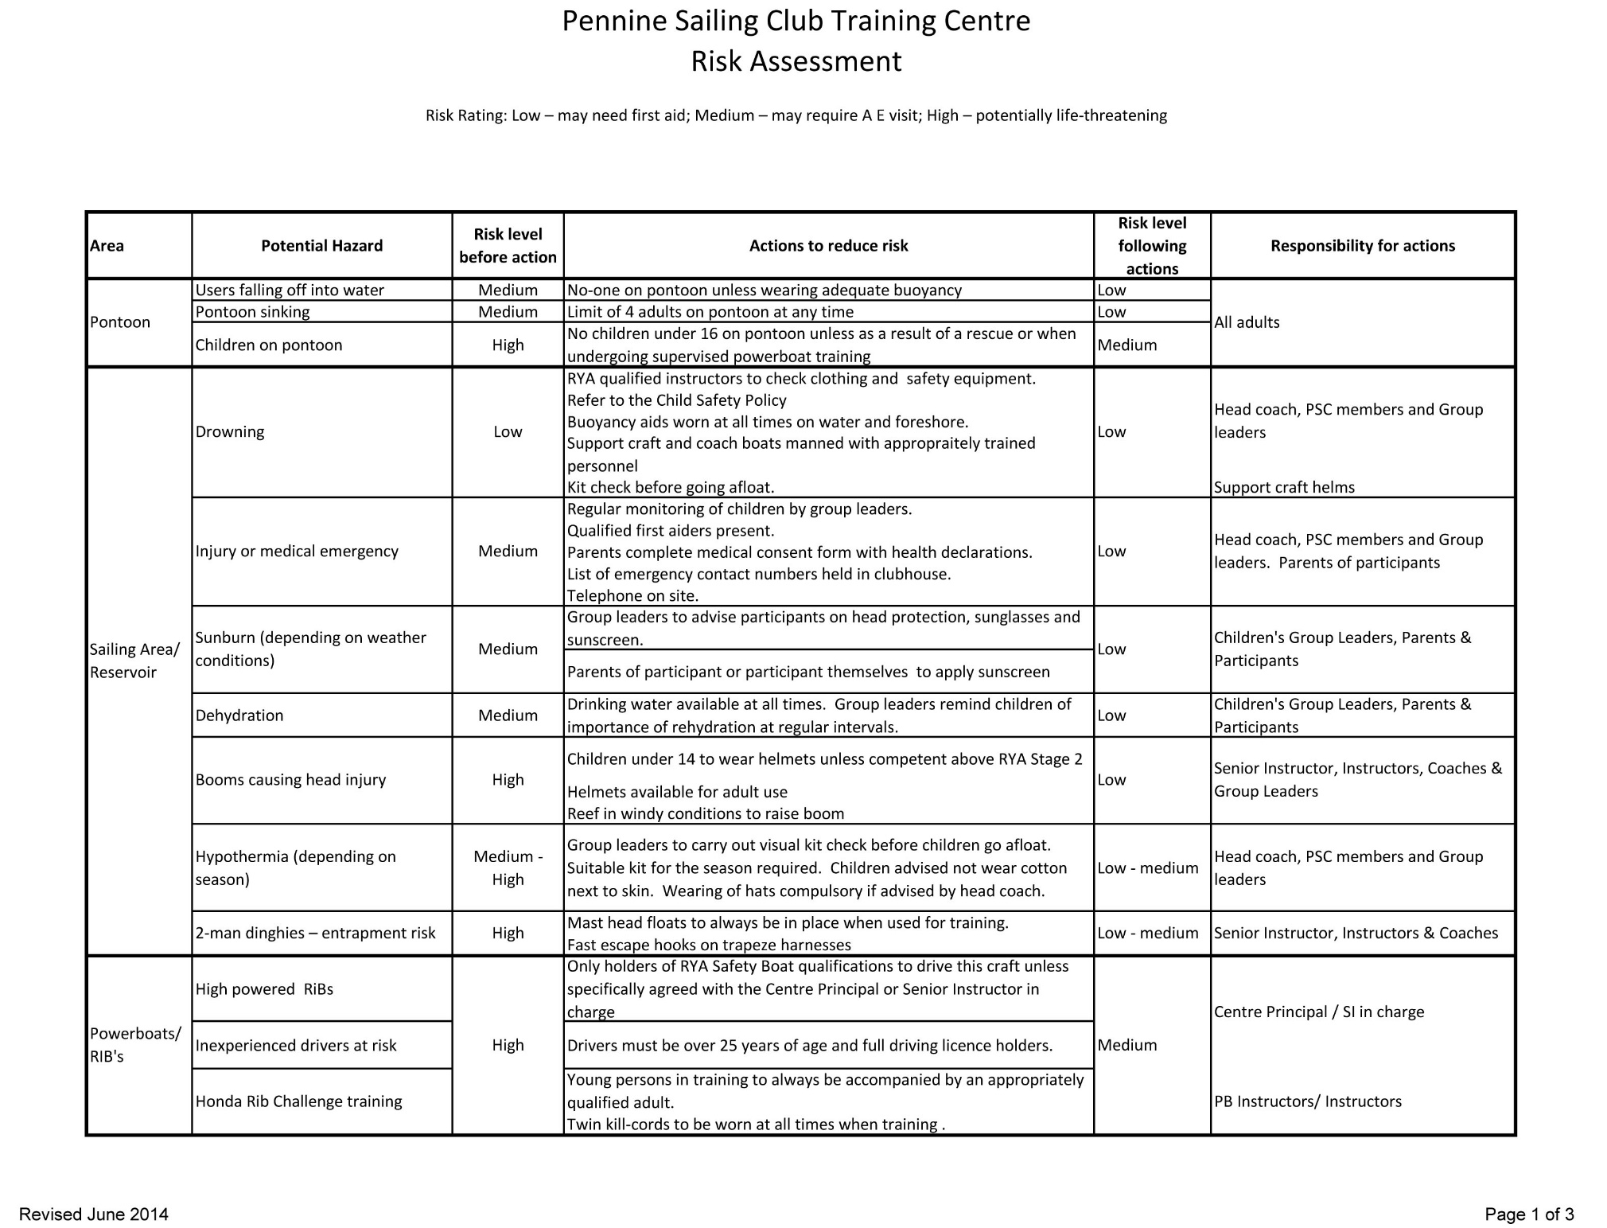
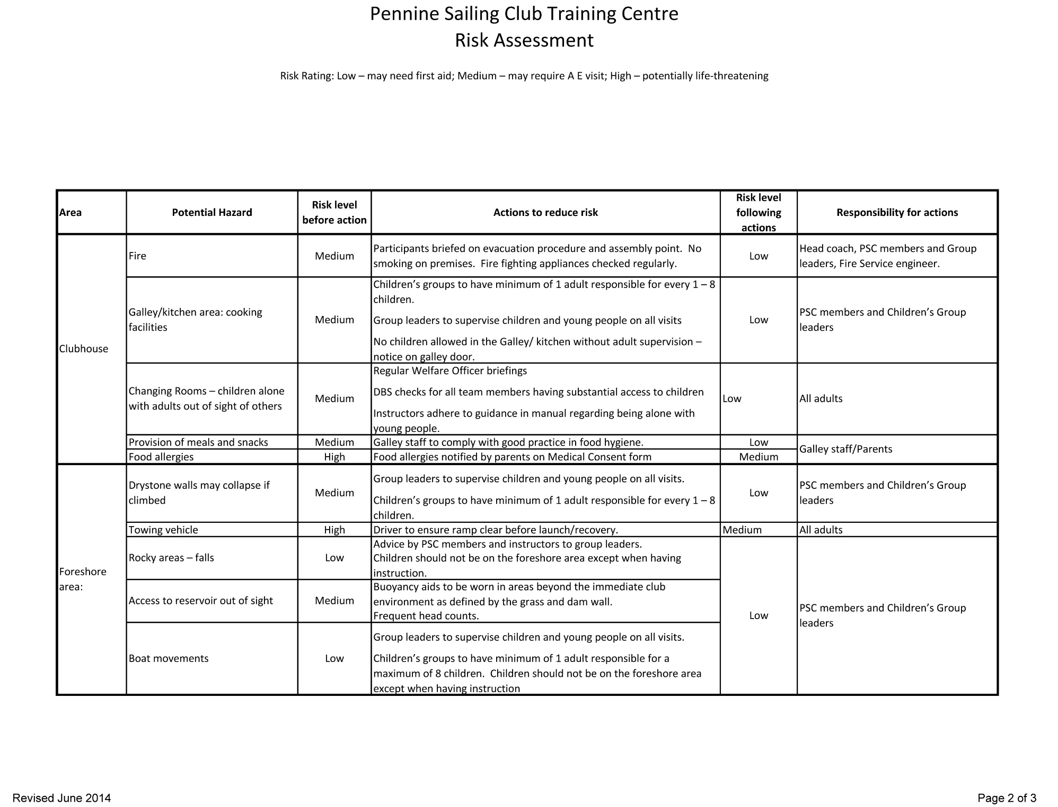
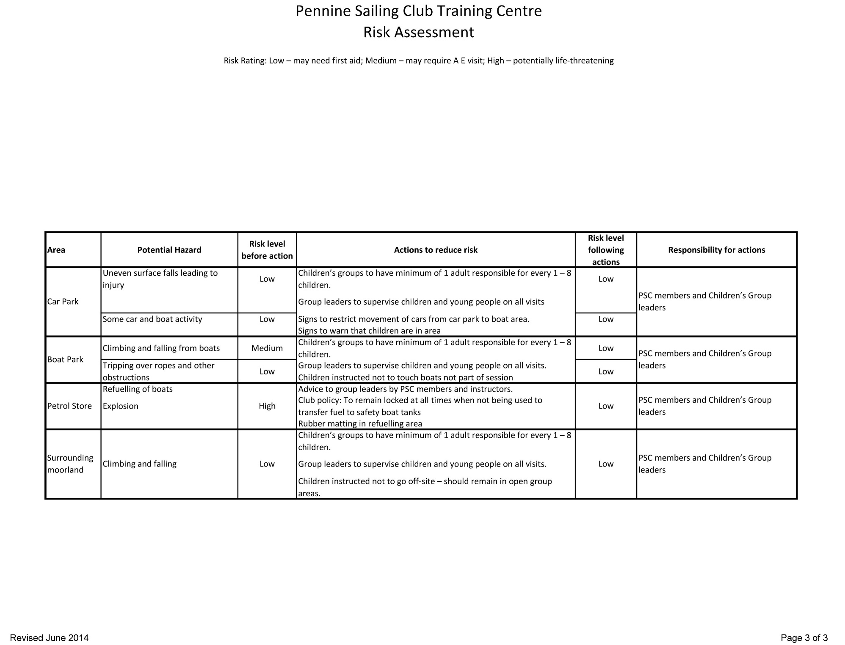

Pennine Sailing Club Training Centre

Equal Opportunities Statement

Pennine Sailing Club is committed to the promotion of equality of opportunity for all people regardless of their age, race, religion, ethnic group, culture, gender, sexual orientation, ability, disability or marital status.

Volunteers:

The club relies on its volunteers to enable all the club’s functions to run smoothly. No volunteer should be disadvantaged or discriminated against in seeking to volunteer or in their service to the club. Volunteers will be allocated duties in accordance with their level of skills, abilities and/or qualifications.

Instructors:

All instructors, whether paid or unpaid, will be given fair consideration. Those working with young people under the age of 18 years must complete a declaration of criminal convictions, including spent convictions. Declaration of a criminal record will only affect an instructor’s appointment if that conviction is for an offence against a child or, in the opinion of the RYA’s Child Protection Officer is such that renders the holder of too high a risk to be permitted to work with young or vulnerable people.

Management Committee:

All full and life members are eligible to be Management Committee members.

Emergency Information

Location of Pennine Sailing Club for emergency services:

Winscar Reservoir
Windle Edge
Dunford Bridge
South Yorkshire
S36 4TF

Phone –0114 3030990

Grid Ref – SE1402 (41494022)

Procedure for dealing
with a major incident

The first priority is the safety of participants and instructors.

The following procedure should then be followed:

- Get a statement from competent witness(es);
- Remove the instructor and key witnesses from the club premises to somewhere you can talk to them away from the press;
- Produce a written statement for the press, such as:
"Pennine Sailing Club regrets to announce the death of a crew member who fell overboard at night from a training yacht. When and where. Our deepest sympathy to the relatives etc. A full statement will be issued at 2pm tomorrow” (give yourself time to collate the information).
- Don't hold a press conference, but decide who will speak to the press;
- Don't allow well-meaning but ill-informed members to make public comments;
- Try to keep a record of whom you have spoken to, who has contacted you etc;
- Inform RYA Training (023 8060 4180) who can assist with compiling your statement to the press;
- If the rescue services have been involved the press will have probably obtained some information from them;
- If there has been a fatality the police will contact the centre and inform the next of kin. Do not publicise the name of the casualty until you know this has been done, even if the press appears to know who it is;
- If your boat has a code of practice certificate you must inform the Marine Accident Investigation Branch (MAIB) within 24 hours. You can do this by phoning 023 8039 5500. They will inform you within 28 days whether they intend to investigate;
- Keep any relevant equipment such as lifejackets, logbooks etc
- If required, send a report to the MAIB (refer to booklet G27).

When dealing with any major incident, it helps if:
- your paperwork is up to date with information such as contact numbers for the next of kin;
- the boats and instructors comply with the club’s safety policy and the RYA ’s conditions of recognition.

INCIDENT REPORT FORM
including dam-wall contacts

This form must be used to notify the Principal of any serious incidents not resulting in injuries, for example theft, fighting, slips or falls, near-misses in support craft etc.

All dam wall contacts MUST be reported.

CIRCUMSTANCES OF INCIDENT

Date: Time of incident:

Weather conditions (if relevant):
Wind direction: Strength: Visibility:

People involved:

What happened?

Where young people were involved have the parents been informed?
Were injuries sustained? Yes/No
Was first aid administered? Yes/No
In the case of suspected theft, have the Police been informed? Yes/No
Was a crime number obtained? Yes / No If yes, state it here:
Name of person reporting incident (in capitals):
Signature: Date:

Action taken to reduce risk of recurrence

Signed Date

Participant Feedback Form

Name of Participant (Optional) ……………………………………...
Date(s) of course ……………………………………
Level of course ………………………………………
Please tick the column which reflects your feelings about your course.
Comments?
1. Your level of enjoyment of the
course
2. Your achievement
3. The training room
4. The changing facilities
5. The catering
6. The equipment provided
7. The cost of the course
8. The cost of equipment hire
9. The friendliness and approachability of the instructors
10. Your overall level of satisfaction

Complaints Procedure Form
Pennine Sailing Club is committed to giving a high standard of safety, care and training.
If you have a problem or complaint about any aspect of the course you should speak to your instructor as soon as possible and they will try to resolve it with you or if they feel it is appropriate they will inform the Senior Instructor.

You may also speak directly to the Senior Instructor after the session. They will try to resolve it with you.
If you are not satisfied you may ask for a Complaints Form (this form) which should be returned to the Principal.
The Principal will then make a written reply to you and make efforts to resolve your complaint. If your complaint cannot be resolved the Principal will explain why. You may take the matter to the Committee of PSC. The decision of the Committee is final.

Name of Trainee
Course Date
Course Name
Instructors
Reason for Complaint
Who did you speak to initially?
When did you first complain?
How did they try to resolve it?
Have you spoken to the Senior Instructor?
How did they resolve it?
How do you think your complaint should be resolved?
Signed
Date

TRAINING BOOKING FORM

Course: |  |  | Dates:
Name of participant
Date of birth |  | Male/Female
Home address
 |  |  |  |  | Postcode
Telephone Number
EMERGENCY CONTACT
Name
Contact Number
Relationship

HEALTH DECLARATION
Details of any medical treatment being received (if none write ‘NONE)

If you suffer from epilepsy, giddy spells, asthma, diabetes, heart condition or anything else you believe may
affect you during your time with us, please provide details:

Declaration
I declare that to the best of my knowledge, I am fit to participate in the course.
Signed |  | Date

Parental Consent (For participants under the age of 18)
I, the parent/guardian of ……………………………………………. give permission to the coaches participating in activities during this event to administer to the named participant first aid treatment if necessary. Further, if the case arises, I authorise the instructors to take my son/daughter to hospital and give my full permission for any treatment required to be carried out in accordance with the hospital’s diagnosis. I understand that I shall be notified as soon as possible of the hospital visit and any treatment given by the hospital.

Signed |  | Date
Name |  | Relationship

RISK STATEMENT
It must be recognised that sailing is by its nature an unpredictable sport and therefore inherently involves an element of risk. By taking part, you agree and acknowledge that:
(i) You are aware of the inherent element of risk involved in the sport and you accept responsibility exposing yourself to such inherent risk whilst taking part;
(ii) You will comply at all times with the instructions of the Instructors particularly with regard to handling of boats, wearing of buoyancy aids and the wearing of suitable clothing for the conditions;
(iii) You accept responsibility for any injury, damage or loss to the extent caused by your own negligence;
(iv) You will not participate whilst your ability to skipper or crew a dinghy is impaired by alcohol, drugs or whilst otherwise unfit to participate;
(v) The provision of patrol boat cover is limited to such assistance, as can be practically provided in the circumstances.

MISCONDUCT
You understand that the Instructors may exclude anyone from a particular session and evict anyone from the premises who refuses to comply with these Registration Terms or who misconducts themselves in any way or who causes damage or annoyance to other persons.

DATA PROTECTION
The information given by you on this form will be used by us to process your registration and for attending to you whilst you are at Pennine SC. We shall also include your name and address on our mailing list. If you do not want to receive our newsletters please tick here ____.

PHOTOGRAPHY
We may take photographs and video footage for use by us in connection with the promotion of us and our activities and/or for training purposes. If you object to the use of these images please tick here____________

CONSENT
I confirm that I have read and fully understand the above Registration Terms and agree to comply with them.
Signed |  | Date

Parental Consent (For participants under the age of 18)
I agree that _______________ may take part in the training. I confirm that I have read through the above conditions with him/her and that she/he understands and agrees with them. I also confirm that he/she takes part in the training with my full agreement that that the particulars given above are correct and complete in all respects.

Signed |  | Date
Name |  | Relationship

Pennine Sailing Club Training Centre
Safety Briefing Checklist

 | Comment
Person in ‘Control’ | SI, Race Officer
Weather Conditions | Now
Weather Forecast
Students | Number, age, experience
Allocations | Instructors, volunteers, boats
Sailing area(s) | No-go zones?
Radio channel/allocation/signals
Medical info of participants
Safety Cover
Instructors | Personal kit check (PFD), 1st aid kit, radio
Students | Suitable clothing, PFD
Other

Type of Craft | Student Instructor Ratio
Crewed dinghies | 3:1 for beginners with instructor on board  Maximum 9:1 but not more than 6 boats per instructor (e.g. 3 boats with 3 students in each or 4 Picos/Toppers with 2 students in each)
Single handed dinghies | 6:1 (applies only whilst the boats are used as single handers)
Powerboats  Levels 1, 2  Safety Boat | 3:1  6:1 (2 boats)

Revised 31/03/17

Signalling on the Water

Action | Meaning | By
Raising and lowering of one/both arms | I need assistance | Sailor
One raised arm | I have a question / I want to tell you something | Sailor
1 whistle  point at one dinghy | Stop what you are doing and stop the boat | Instructor
1 whistle  beckon at one dinghy | Stop what you are doing and come to me / follow me | Instructor
2 whistles  hands to head | Everyone stop what you are doing and come to me / follow me | Instructor
3 whistles  point to shore | Everyone go to shore | Instructor

Pennine Sailing Club Training Centre
Emergency Action Plan

This emergency action plan is designed to cover incidents both on and off the water that put people’s lives and health at risk.
1 Emergency Action Plan

1.1 Background
PSC has responsibility for all club members whilst training, coaching and racing is underway and at other times when a PSC Safety Boat is on the water. It is the responsibility of all site users to support each other and the team that is directing the incident.

1.2 Alerting
Club members should bring the incident to the attention of the Instructors, Coach or Race officer whichever is most appropriate to bring the incident to a satisfactory conclusion.
Any club member on the water should upon seeing a boat or persons on the water in distress should alert Instructor /coach /RO as above or by using a whistle, raising a paddle to attract attention, raising and lowering of arms, shouting, to attract the attention of safety boats patrolling. Additionally, they should stand by to offer any immediate assistance possible.

1.3 Instructors & Coaches
Upon being informed of an incident the Instructors or coaches shall make a judgement as to whether the incident is minor and can be dealt with by the club safety crew or other nearby safety crew without compromising the safety of the rest of the training class.
Request emergency services if the incident is urgent and a threat to health. The Instructors shall then stand by to offer any assistance required e.g. abandon the class and send all other boats to the shore. The Instructors and coaches should co-ordinate the management of the incident with the Safety
Boat.

1.4 Race Officers
The Race Officer’s responsibility is as for Instructors, and coaches, but with the added responsibility of ensuring that the racing fleet is safe. They may choose to continue racing, if adequate safety cover is in place, or shorten course to give a controlled end to racing, or abandon racing altogether and send boats ashore.

1.5 Safety Boat Crew
The prime task of the Safety Boat is to deal with the incident on the water and preserve life and health of those involved. Upon seeing or being informed of an incident the Safety Boat crew shall attend as quickly as is safe to do so and should Communicate with Instructors /Race Officers unless completely sure that it is minor and that the sailors are not injured. If there is doubt as to the sailor’s ability to continue or if in doubt of their ability to manage the incident without compromising safety of the rest of the fleet the safety boat crew should raise
the alarm with Instructors /Race Officers.
The Safety Boat crew will endeavour to stop the injury/ incident from becoming more serious and enable recovery to start by
a) ensuring the casualty has an airway; which may mean releasing from entrapment by righting boat as quickly as possible or cutting clothing, sheets or halyards to free person. N.B. Cutting the rig away is not recommended as it
will probably sink.
b) by considering if the crew should/ can be helped into the safety boat or should/can be immobilised and left in situ.
c) administer First Aid mouth to mouth /chest compressions, stop serious bleeding if required.
d) evacuate casualty to shore (and await emergency services an Ambulance is required)

1.6 Other sailors
Other sailors should stand by to support the incident team as required. This may be providing additional personnel to enter the water to assist in recovery of a casualty, providing first aid or relaying messages between parties.

1.7 The Shore Party,
If present, a separate Shore Party will perform the following actions, otherwise the Instructors/Race Officers and Safety Boat crew will;
• administer any further first aid e.g. keep warm, treat for shock and if necessary keep in contact with Emergency Services and follow their directions.
• await emergency services, take casualty to hospital or doctors, send casualty to hospital or doctors, advise casualty to seek medical treatment or a check-up. A responsible adult should accompany any under 18 or vulnerable adult or injured person to hospital and remain there while treatment is given or until parents or next of kin arrives.
• keep crowds away, take those involved but not injured to the club room and request others to leave. Note it is important to offer support to anyone involved in an incident that has resulted in serious injury.
• inform the Commodore or other member of committee.
• make no comment to media or persons not involved.
• The RO/ Safety Boat Crew will enter the incident in the accident book if the casualty does not need further medical attention or complete a major incident log. The Commodore or member of the Committee will make a report major incident RYA who will provide advice and guidance, 24-hour access throughout the year.
• The Commodore /Vice Commodore / Principal will offer support to members involved and will try to maintain proper confidentiality by asking all involved to only speak to the official bodies e.g. Police, RYA, RIDDOR and not to discuss the situation openly or make comments to the press.

2 Procedure for dealing with a major incident
The first priority is the safety of participants and instructors.

The following procedure should then be followed:
- Get a statement from competent witness(es);
- Remove the instructor and key witnesses from the club premises to somewhere you can talk to them away from the press;
- Produce a written statement for the press, such as:
"Pennine Sailing Club regrets to announce the death of a crew member who fell overboard at night from a training yacht. When and where. Our deepest sympathy to the relatives etc. A full statement will be issued at 2pm tomorrow” (give yourself time to collate the information).
- Don't hold a press conference, but decide who will speak to the press;
- Don't allow well-meaning but ill-informed members to make public comments;
- Try to keep a record of whom you have spoken to, who has contacted you etc;
- Inform RYA Training (023 8060 4180) who can assist with compiling your statement to the press;
- If the rescue services have been involved the press will have probably obtained some information from them;
- If there has been a fatality the police will contact the centre and inform the next of kin. Do not publicise the name of the casualty until you know this has been done, even if the press appears to know who it is;
- If your boat has a code of practice certificate you must inform the Marine Accident Investigation Branch (MAIB) within 24 hours. You can do this by phoning 023 8039 5500. They will inform you within 28 days whether they intend to investigate;
- Keep any relevant equipment such as lifejackets, logbooks etc
- If required, send a report to the MAIB (refer to booklet G27).

When dealing with any major incident, it helps if:
- your paperwork is up to date with information such as contact numbers for the next of kin;
- the boats and instructors comply with the club’s safety policy and the RYA ’s conditions of recognition.

Minor |  | More Serious |  | Major
 |  | Check you are SAFE
 |  | Contain incident. Ensure everyone is on a safe boat or holding on to a safe boat
 |  | Request assistance
Treat any casualty whilst ensuring safety of others |  | Treat any casualty whilst ensuring safety of others |  | Call 999 with details of emergency  What, where, when, how many, who?
Arrange for casualty to go ashore if further treatment needed |  | Take to club house for full First Aid kit |  | Escort rest of sailors ashore.  Supervise juniors
Report to Race Officer or Senior Instructor |  |  |  | Treat any casualty.  First Aid is in club house
Inform parents of juniors |  | Account for rest of group.  Sign trainees out |  | Await ambulance  Account for rest of group.  Sign trainees out
Fill in the Accident Report |  | Fill in accident form. |  | Inform next of kin, Commodore, Principal & RYA.

Pennine Sailing Club Training Centre
Emergency Action Plan

For all emergencies:

For life threatening and serious emergencies phone 999 immediately.

The club address is
Winscar Reservoir
Windle Edge
Dunford Bridge
South Yorkshire
S36 4TF

Phone – 01226 763399

Grid Ref – SE1402 (41494022)

The first aid station is in the clubhouse, but for life threatening emergencies it is more appropriate to bring the equipment to the casualty.
The defibrillator is located next to the main entrance door of the club.
Call for help immediately.
If an ambulance is attending, a member of the shore party should go to the end of the lane, to the junction with Dunford Road to flag down the ambulance and guide them to the scene.
This emergency action plan is designed to cover incidents both on and off the water that put people’s lives and health at risk.

Emergency Action Plan

For Incidents on the water:
Please note that lives and safety come before boats. If there is any danger to the crew, deal with the incident and make sure that they are safe before worrying about the boat.

Person responsible and the ‘Control’ will usually be the Senior Instructor at the Centre or if not available, the Race Officer running the racing.

The rescue boats should have their VHF radios tuned to channel 37 (or M1) at all times. The Control will have a radio at all times, whether on the water or not.

There are 5 levels of incident that can be called:

Zulu, Zulu, Zulu | Get all people to shore immediately.  Abandon boats. All people on the water are in imminent danger.
Tango, Tango, Tango | Clear the water immediately  Don’t panic. Safely get all sailing boats to shore as quickly as possible.  There is a clear and immediate danger.
Code Red | We have a blood injury on board, prepare 1st aid kit.
Pan Pan, Pan Pan, Pan Pan | This boat needs assistance, but everybody is ok
Mayday, Mayday, Mayday | This boat needs assistance urgently

Where boats are left abandoned on the reservoir and the casualties are not in immediate danger, consider the application of red marker tape, or some other marker or fender to show that the crew have been accounted for.

If any rescue boat attends an incident on the water where the safety of a crew member is at risk, they should contact control immediately. If anyone’s life seems to be in danger they should ask control to ring 999 immediately.

In the event of someone losing consciousness out on the lake, waste no time getting them ashore. It is not possible to do CPR in a RIB. Having picked up the casualty the rescue boat crew should head straight back to the pontoon as soon as possible, while alerting the duty officer by radio as to the situation.

The easiest way to get an unconscious person safely out of a RIB is to drive the RIB straight to the pontoon. A team of helpers can then safely transfer the casualty to the stretcher. If necessary, the RIB tubes can be deflated.

If the casualty has had a serious back or neck injury, try to reduce movement to as little as possible.
If someone is unconscious but breathing normally, and has not had a back or neck injury, place in the recovery position and observe carefully while waiting for the ambulance to arrive.

If a casualty is unresponsive and does not appear to be breathing normally, immediately get the defibrillator and follow the instructions. The AED defibrillator is located next to the main entrance door of the club.

Data Privacy Policy
1. About this Policy
1.1 This policy explains when and why we collect personal information about our members and instructors, how we use it and how we keep it secure and your rights in relation to it.
1.2 We may collect, use and store your personal data, as described in this Data Privacy Policy and as described when we collect data from you.
1.3 We reserve the right to amend this Data Privacy Policy from time to time without prior notice. You are advised to check our website www.pennine-sc.co.uk or our Club noticeboard regularly for any amendments (but amendments will not be made retrospectively).
1.4 We will always comply with the General Data Protection Regulation (GDPR) when dealing with your personal data. Further details on the GDPR can be found at the website for the Information Commissioner (www.ico.gov.uk). For the purposes of the GDPR, we will be the “controller” of all personal data we hold about you.

2. Who are we?
2.1 We are Pennine SC. We can be contacted at Winscar Reservoir, Dunford Bridge, South Yorkshire S36 4TF; telephone 0114 3030990; email commodore@pennine-sc.co.uk.

3. What information we collect and why.
Type of information | Purposes | Legal basis of processing
Member's name, address, telephone numbers, e-mail address(es) | Managing the Member’s membership of the Club. Keeping in touch with the Member (including by newsletter). Managing the duty roster | Performing the Club’s contract with the Member. For the purposes of our legitimate interests in operating the Club. For the purposes of our legitimate interests in operating the Club.
The names and ages of the Member’s dependants | Managing the Member’s and their dependants’ membership of the Club | Performing the Club’s contract with the Member
Emergency contact details | Contacting next of kin in the event of emergency | Protecting the Member’s vital interests and those of their dependants
Date of birth / age related information | Managing membership categories which are age related | Performing the Club’s contract with the Member
Gender
 | Provision of adequate facilities for members. Reporting information to the RYA | For the purposes of our legitimate interests in making sure that we can provide sufficient and suitable facilities (including changing rooms and toilets) for each gender. For the purposes of the legitimate interests of the RYA to maintain diversity data required by Sports Councils
The Member’s name, boat name and sail number | Managing race entries and race results. Publishing race results at the club and with other clubs, class associations, and the RYA, and providing race results to local and national media. Allocating moorings and compound spaces. | For the purposes of our legitimate interests in holding races for the benefit of members of the Club. For the purposes of our legitimate interests in promoting the Club. For the purposes of our legitimate interests in operating the Club
Photos and videos of Members and their boats | ... Putting on the Club’s website, social media pages, newsletter and using in press releases | Consent. We will seek the Member’s consent on their membership application form and each membership renewal form and the Member may withdraw their consent at any time by contacting us by e-mail or letter.
The Member’s name and e-mail address | Creating and managing the Club's online Membership Directory | Consent. We will seek the Member’s consent on their membership application form and each membership renewal form. The Member may withdraw their consent at any time by contacting us by e-mail or letter to tell us that they no longer wish their details to appear in the Membership Directory
Bank account details of the member or other person making payment to the Club | Managing the Member’s and their dependants’ membership of the Club, the provision of services and events | Performing the Club’s contract with the Member
The Member’s name and e-mail address, whilst a current member and for up to [a year] after ceasing to be a member of the Club | Passing to the RYA for the RYA to conduct surveys of Members and former members of the Club. See paragraph 5.3 below. | For the purposes of our legitimate interests in operating the Club and / or the legitimate interests of the RYA in its capacity as the national body for all forms of boating.
Instructor’s name, address, email addresses, phone numbers and relevant qualifications and/or experience. | Managing instruction at the Club. | For the purposes of our legitimate interests in ensuring that we can contact those offering instruction and provide details of instructors to members.
Name, e-mail address and telephone number of each Club Officer | Information published on Club’s website, in Club’s newsletter and other publications, in the Club’s marketing materials and made available to the RYA, in each case as a point of contact at the Club.  For the purposes of our legitimate interests in operating and promoting the Club Name, e-mail address and telephone number of each Club committee member Information published on Club’s website | For the purposes of our legitimate interests in operating and promoting the Club
Employees and representatives of suppliers to the Club | Entering into and managing arrangements with suppliers | Entering into and performing contracts with suppliers

4. How we protect your personal data
4.1 We will not transfer your personal data outside the EU without your consent
4.2 We have implemented generally accepted standards of technology and operational security in order to protect personal data from loss, misuse, or unauthorised alteration or destruction.
4.3 Please note however that where you are transmitting information to us over the internet this can never be guaranteed to be 100% secure.
4.4 For any payments which we take from you online we will use a recognised online secure payment system.
4.5 We will notify you promptly in the event of any breach of your personal data which might expose you to serious risk.
5. Who else has access to the information you provide us?
5.1 We will never sell your personal data. We will not share your personal data with any third parties without your prior consent (which you are free to withhold) except where we are required to do so by law or as set out in the table above or in paragraphs 5.2 and 5.3 below.
5.2 We may pass your personal data to third parties who are service providers, agents and subcontractors to us for the purposes of completing tasks and providing services to you on our behalf (e.g. to print newsletters and send you mailings). We do this for the purpose of our legitimate interests in operating the Club and for performing our contract with you. However, we disclose only the personal data that is necessary for the third party to deliver the service and we have a contract in place that requires them to keep your information secure and not to use it for their own purposes. It is possible that third parties may themselves engage others (subprocessors) to process your data. Where this is the case third parties will be required to have contractual arrangements with their sub-processor(s) that ensure your information is kept secure and not used for their own purposes.
5.3 We may also pass your personal data to the RYA for the purposes of carrying out surveys when it is in the legitimate interest of the club and the RYA to do so. The RYA may use third parties to carry out the surveys but disclose only the personal data that is necessary for the third party to do so and will have a contract in place that require the third party to keep your information secure and not to use it for their own purposes.
6. How long do we keep your information?
6.1 We will hold your personal data on our systems for as long as you are a member of the Club and for as long afterwards as it is in the Clubs’ legitimate interest to do so or for as long as is necessary to comply with our legal obligations. We will review your personal data every year to establish whether we are still entitled to process it. If we decide that we are not entitled to do so, we will stop processing your personal data except that we will retain your personal data in an archived form in order to be able to comply with future legal obligations e.g. compliance with tax requirements and exemptions, and the establishment, exercise or defence of legal claims.
6.2 We securely destroy all financial information once we have used it and no longer need it.
7. Your rights explained
7.1 It is important that you understand what rights you have in respect of the Personal Data and Special Category Personal Data that we hold about you. To let us know that you wish us to exercise any of your rights outlined above please contact Alan Waterworth membership@pennine-sc.co.uk
(a) The right to be informed (knowing how we will use your data). You have the right to be told how we will use your Personal Data – which is set out in This Notice.
(b) The right of access (being provided with copies of your data). You have the right to ask us to provide you with a copy of your Personal Data. We will supply any information you ask for as soon as possible but may take up to 1 month once we are satisfied as to your identity. We will not charge you for this. This is called a data subject access request.
(c) The right to rectification (changing incorrect information we hold). If you believe our records are inaccurate you have the right to ask for those records concerning you to be updated. Contact details for any requests can be found above.
(d) The right to be forgotten (erasure) (requesting deletion of your Personal Data). In some cases, you have the right to be forgotten (i.e. to have your Personal Data deleted from our database).
(e) The right to restrict processing (limiting how we use your data). In certain situations you have the right to ask for processing of your Personal Data to be restricted because there is some disagreement about its accuracy or legitimate usage.
(f) The right to data portability (moving your data in a useable format). You have the right to request the Personal Data you provided to us, in a structured, commonly used and machine-readable format and/or transmit that data to a third party - in certain situations.
(g) The right to object (when we must stop processing your data). You have the right to object to us processing data purely for our legitimate interests. If you make such a request, we must stop processing your Personal Data unless: we can demonstrate compelling legitimate grounds for the processing, which override your interests, rights and freedoms; or the processing is for the establishment, exercise or defence of legal claims.
(h) The right not to be subject to automated decision making including profiling (making a decision solely by automated means without any human involvement). The right not to be subject to a decision based solely on automated processing (including profiling) that produces legal effects concerning you or similarly significantly affects you. Pennine SC does not undertake automated decision making or profiling.
7.2 You have the right to take any complaints about how we process your personal data to the Information Commissioner: https://ico.org.uk/concerns/ 0303 123 1113. Information Commissioner's Office Wycliffe House Water Lane Wilmslow Cheshire SK9 5AF
7.3 For further information on each of those rights, including the circumstances in which they apply, please see the Guidance from the UK Information Commissioner’s Office (ICO) on individuals’ rights under the General Data Protection Regulation.

